***a)*** What is the average budget for the Coding Competition and the Welcome Party Activities? Present your result in a column entitled ‘Average’.

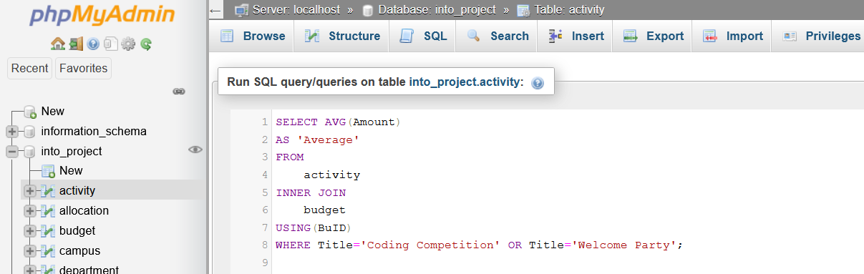

**Successful.**

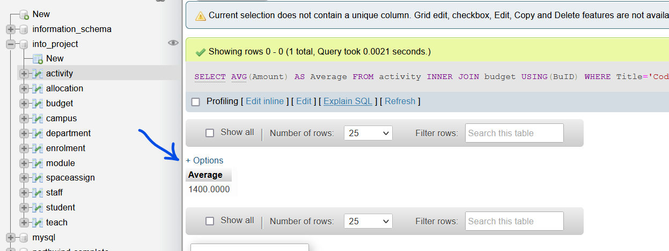

***b)*** Write an SQL query to return the details (i.e. StaffID, the name and campus address) of the staff members whose contract are due to finish in the year 2019.

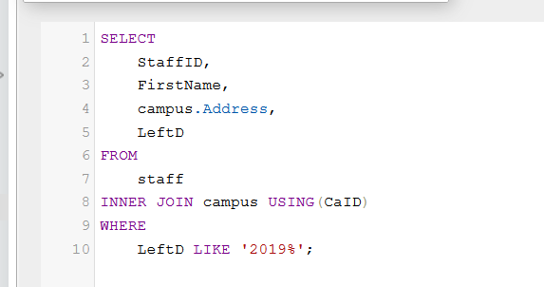

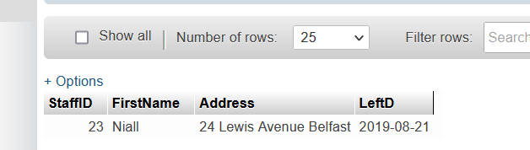

**c) Update the campus table with additional campus information:**

Address = “122, Pineapple Avenue, New York”

Campus Manager = “Michael Carlos”

Country = “USA”

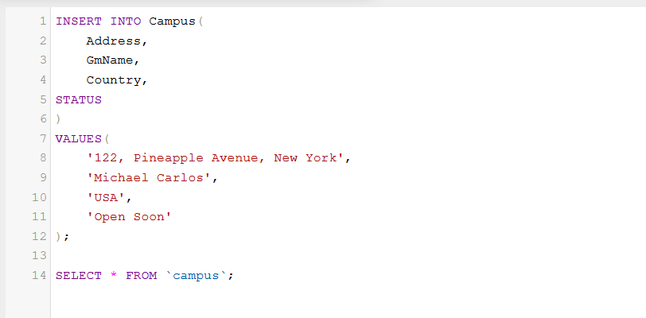Status = “Open Soon”

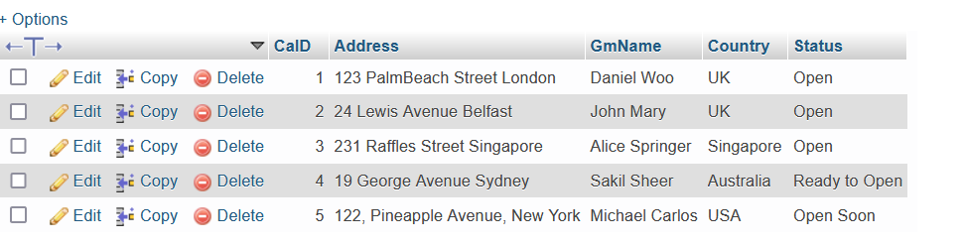

1. ***d)*** Find the list of staff (to include their salutation/title, first name, last name) who work in the EEECS department.

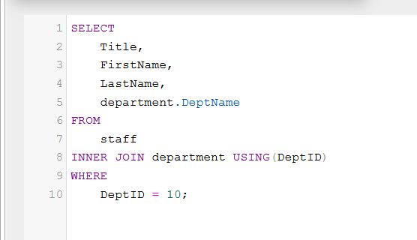

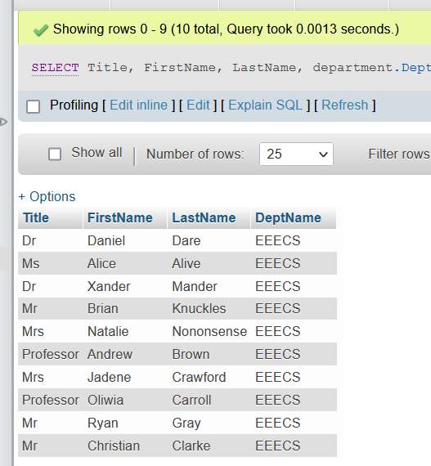

1. ***e)*** Get an alphabetical list of the top 10 staff members.

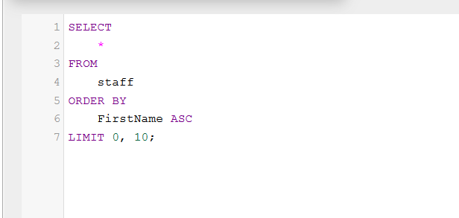

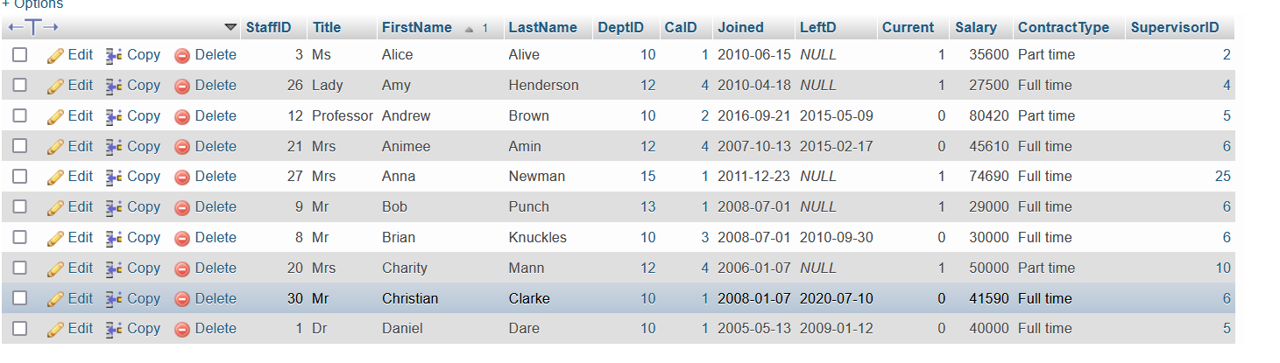

1. ***f)*** Perform a count of the number of activities of each staff member, and output the first names and last names of staff members who were allocated with activities. Do not count staff members who were not allocated to any activity.

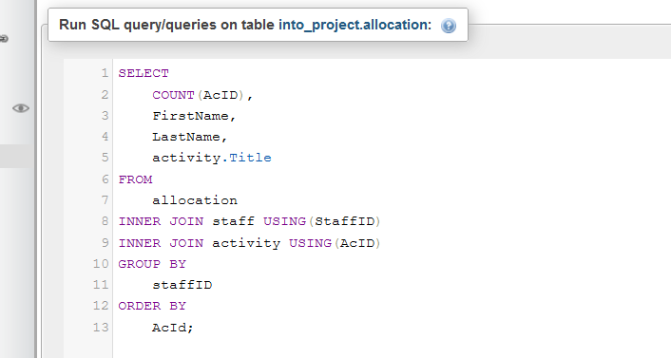

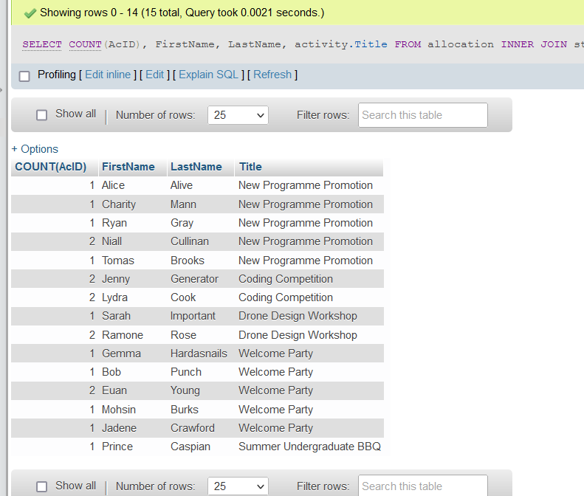

1. ***g)*** Produce a list of the students (names, addresses and scores) who are taking the module ‘Java Programming’. Show your result ordered by the score, from highest to lowest.

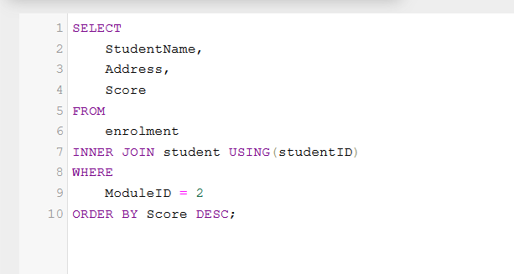

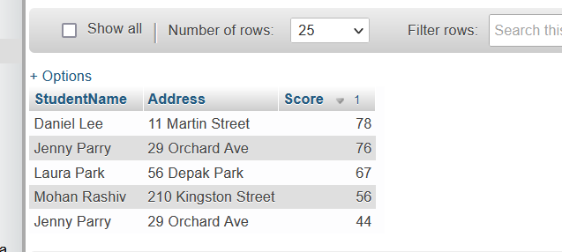

1. ***h)*** What is the total budget that has been approved by Lisa Amy?
   * + 1. Show the result in a column called “Lisa’s Spend”.

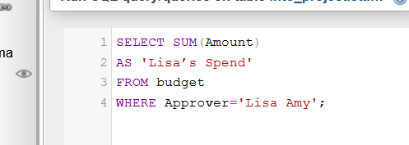

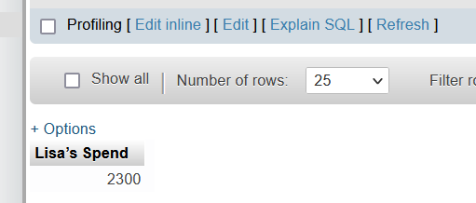

1. ***i)*** Find all the staff whose last name begins with ‘C’ and are also working in the London Campus.

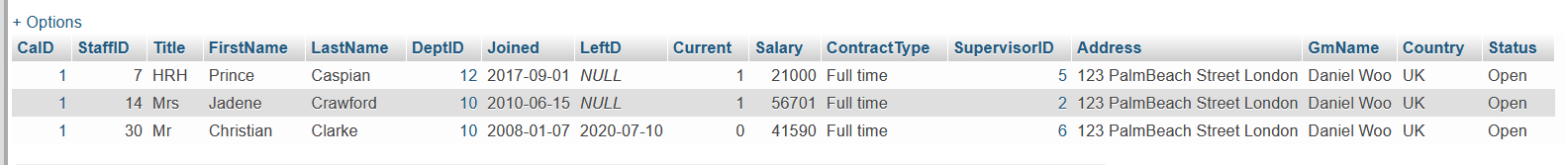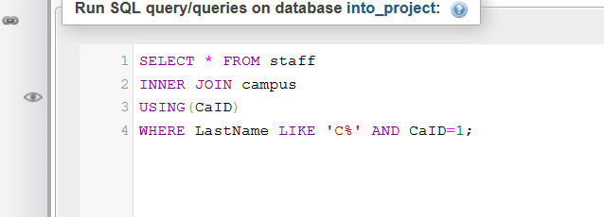

1. ***j)*** Write an SQL query to output the details of the student who had the second highest score for the academic year 2020. Your work should allow for the output screen to show the student’s name, the module taken, and whether

